
American International University-Bangladesh (AIUB)
Department of Computer Science
Faculty of Science &Technology (FST)
Summer 25 26
SHASHROY BAZAR
Software Requirement Engineering
Sec: A
Project submitted
By
Israt Jahan Surovy (23-54972-3)
Mishal (24-55979-1)
Siam Hossain (24-56637-1)

Checked By Industry Personnel (Optional)

Name: Md. Shajahan Islam Sani

Designation: Project Manager II

Company: Brain Station 23 PLC.

Sign:

Date:

- PROBLEM DOMAIN
  - Background to the Problem
Every day, restaurants, supermarkets, grocery stores, pharmacies, clinics, caterers, and other businesses may have food or medicine that remains unsold even though it is still safe and usable. Food may be close to its best-before or expiry period, while pharmacies and healthcare-related organizations may have sealed and unexpired medicine that is unlikely to be sold within the normal sales period. When there is no proper redistribution mechanism, a significant portion of these products may eventually be discarded.
At the same time, many people, especially low-income individuals and families, struggle to purchase necessary food and healthcare products at regular market prices. NGOs, shelters, and charitable organizations also require affordable or donated products to support vulnerable communities.
Therefore, two problems exist simultaneously: usable products are being wasted while other people are struggling to afford those same types of products.
In Bangladesh, surplus redistribution is often handled through individual donations, NGOs, charitable activities, social-media posts, personal communication, or informal networks. Although these approaches can help people, they may not provide a centralized and structured system for verifying donors and merchants, checking product safety and expiry information, finding nearby products, controlling purchases, processing payments, tracking orders, or measuring the overall social impact.
Root Causes of the Problem:
The major root causes identified for this problem are:
- Lack of an organized redistribution platform: There is no single structured system through which different types of verified businesses can conveniently list their usable surplus products for sale or donation.
- Poor communication between surplus providers and people in need: A business may have surplus products, while people or organizations nearby may need them, but there is no efficient way for them to find each other.
- Dependence on informal channels: Donations and redistribution are frequently arranged through personal contacts or social-media groups, which makes the process difficult to manage and monitor.
- Limited verification and safety control: Informal redistribution methods may not provide proper verification of sellers, donors, products, expiry dates, or recipients.
- Lack of geographical coordination: A product may be available in one area, but potential recipients may not know that the product is available nearby.
- Fear of hoarding or misuse: Extremely discounted or donated products may be purchased in large quantities by a small number of users unless proper quantity restrictions are applied.
- Limited impact tracking: Traditional donation processes often make it difficult to measure how many products have been saved from waste, how many people have benefited, and how much social impact has been created.
  - Solution to the Problem
- What are the solutions you are going to propose to deal with the problem? why is this
solution is particularly appropriate to solve the problem? Is the solution feasible to the
meet the business objective?
- Provide a short description of the software being specified and its purpose, including relevant benefits, objectives, and goals
- Existing studies presented in the problem area. What are the existing software solutions
are available to solve the problem?

- SOLUTION DESCRIPTION

  - System Features
- List down the system functional requirements and quality attributes in each system feature that is necessary for the software.

  - UML Diagrams
- Use Case Diagram
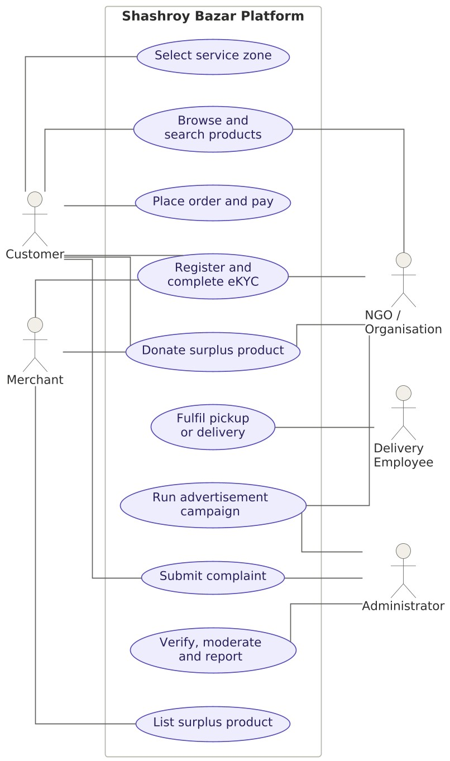
Figure 1 — Use case diagram, Shashroy Bazar
- Class Diagram
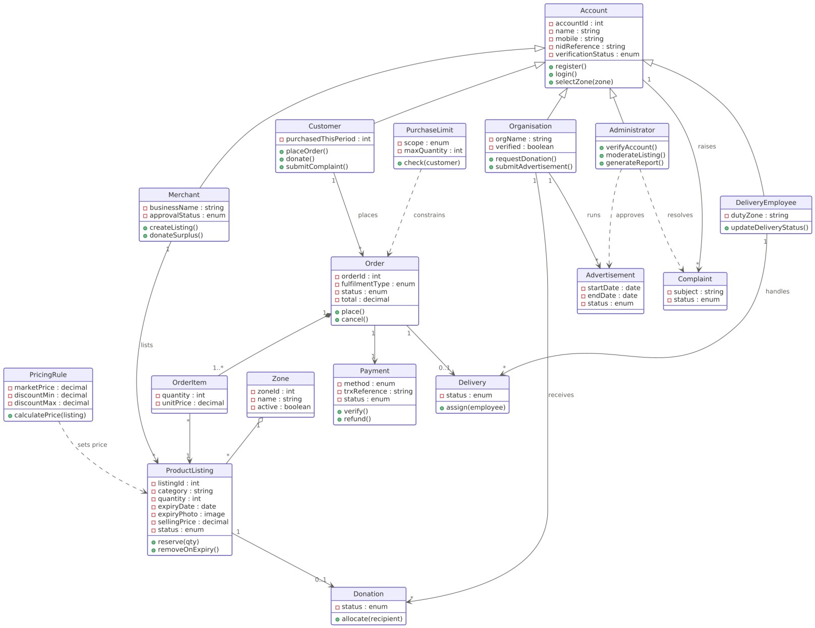
Figure 2 — Class diagram, Shashroy Bazar
- Sequence Diagram
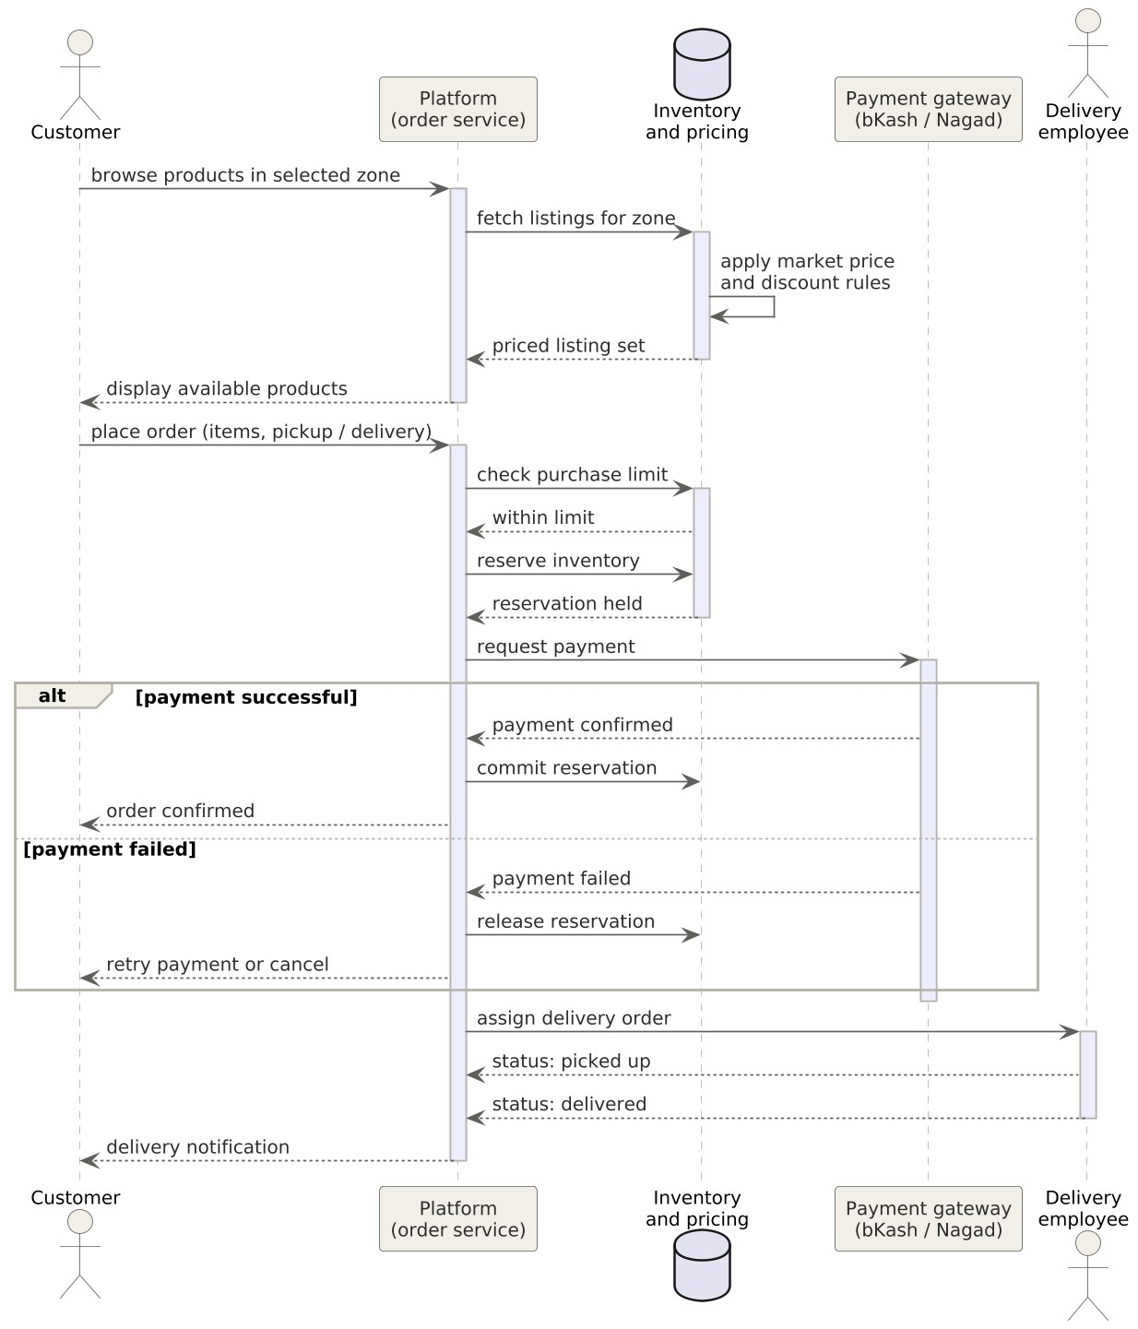

Figure 3 — Sequence diagram, place order through delivery

- Social Impact

How society will be benefitted from your project idea.

- Development Plan with Project Schedule

In your document you should provide a proper development plan that presents in every SDLC including project schedule. To prepare project schedule use any project management tools. Don’t make the schedule in MS word/ excel.

- Marketing Plan
In your document you should provide proper marketing plan that will make your idea popular among the community so that you can make business. Marketing plan should have short term, long term and continuous plan.

- Cost and Profit Analysis
In your document you should provide proper cost analysis including development and marketing cost. Then you can show profit analysis. Based on your profit analysis investors will be agreed to invest on your idea.

- Reference
Put all the references you have used during the project work.

